

**Name: M Shahzad**

**Class: BSDSM-F22-016**

**Section: 5-A**

### Lab 12 - Task

### Submitted To: Sir Rasik Ali

### Lab 12 - Task

### Task 1; what is difference between “VLAN & Inter-VLAN Routing”, explain with Example (draw structure in cisco

### ****Difference between VLAN and Inter-VLAN Routing****

| **Aspect** | **VLAN** | **Inter-VLAN Routing** |
| --- | --- | --- |
| **Definition** | A **Virtual Local Area Network (VLAN)** is a logical grouping of devices in a network. It isolates devices within the same network. | **Inter-VLAN Routing** allows communication between different VLANs using a router or Layer 3 switch. |
| **Purpose** | Segments a network to improve performance, manageability, and security. | Enables communication between devices in different VLANs. |
| **Communication** | Devices in the same VLAN can communicate directly. | Devices in different VLANs cannot communicate without a routing mechanism. |
| **Implementation** | Configured on a switch by assigning ports to specific VLANs. | Implemented using a router or Layer 3 switch to route traffic between VLANs. |
| **Key Benefit** | Network segmentation. | Facilitates communication between VLANs. |
| **Examples** | VLAN 10 for HR (192.168.1.0/24) and VLAN 20 for IT (192.168.2.0/24). | Traffic from VLAN 10 (HR) to VLAN 20 (IT) routed via a Layer 3 device. |

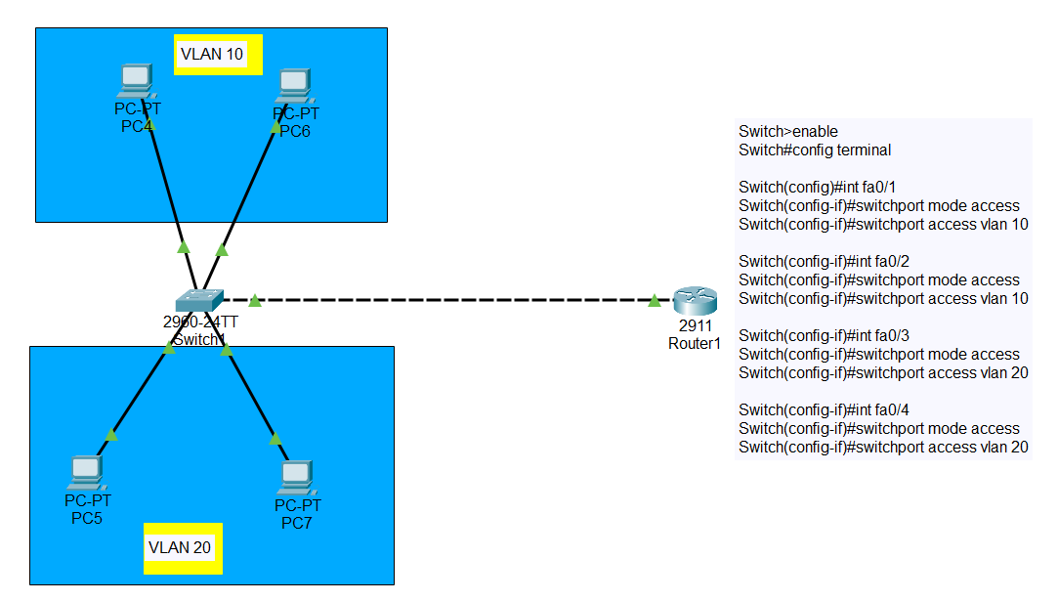

Inter VLAN

